
Dashboard Design

Date | 31 October 2026
Team ID | Not applicable – Individual Project
Project Name | EV Market Performance & Insights
Maximum Marks | 5 Marks

Activity 1: Interactive and visually appealing dashboards
The EV Market Performance & Insights dashboard is built in Tableau Public Desktop using a CSV data source. It brings key performance indicators and market comparison charts into one view, with a Tableau Story to present the main observations. It is not a Streamlit or Snowflake dashboard.
- Clear and Intuitive Layout
- Use Appropriate Visualizations
- Colour and Theming
- Interactive Filters and Slicers
- Drill-Down Capabilities
- Responsive Design
- Custom Visuals and Icons
- Use of Infographics

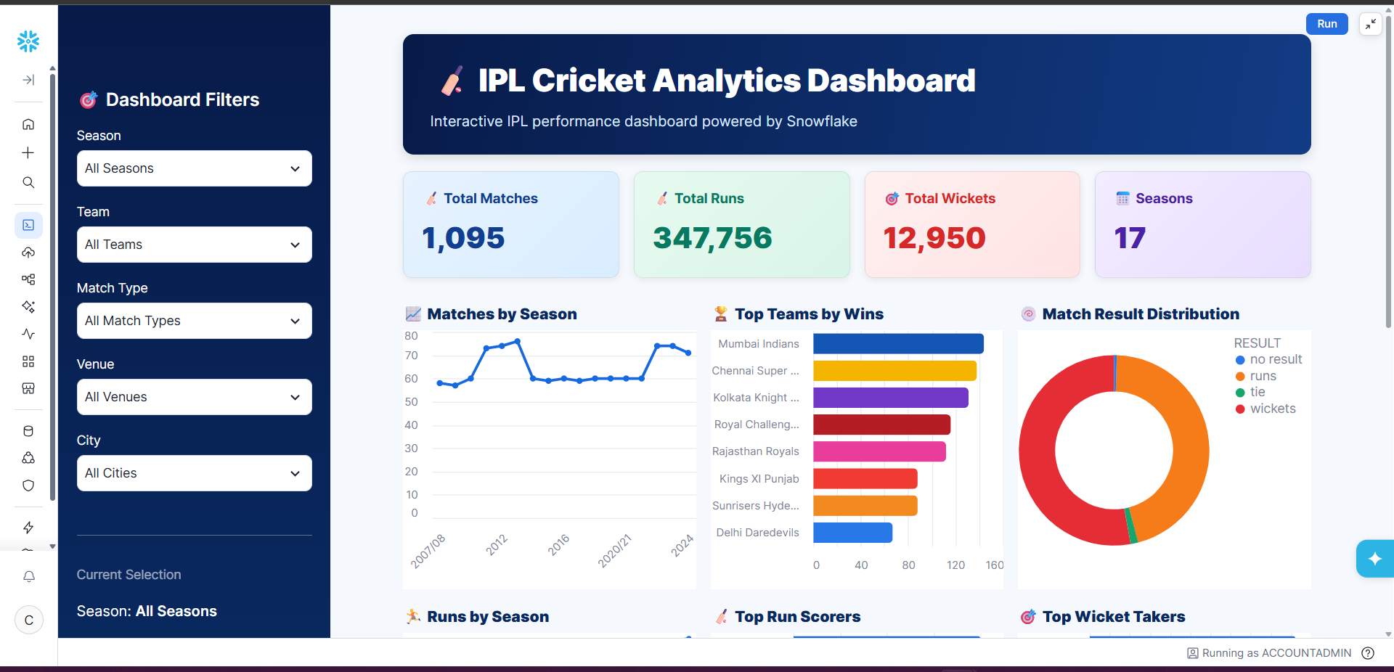
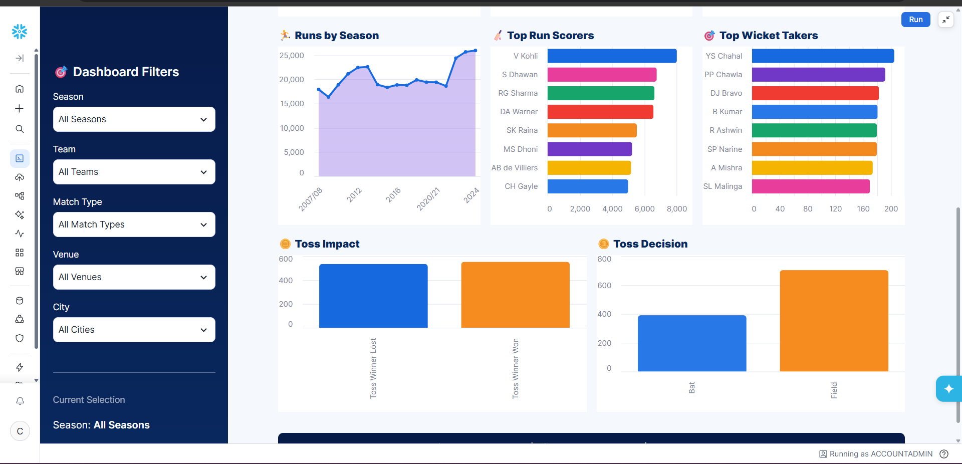
Note: Highlight the major outcomes in form of bullet points
Sample:
Here are five potential outcomes from the dashboard image provided:
- Mumbai Indians emerge as the strongest team by wins
Mumbai Indians are shown at the top of the Top Teams by Wins chart, indicating consistently strong performance across IPL seasons.
- Batting performance is dominated by a few key players
V. Kohli leads the Top Run Scorers chart, followed by players such as S. Dhawan, RG Sharma, and DA Warner. This highlights the importance of high-performing batsmen.
- Wicket-taking performance is concentrated among leading bowlers
YS Chahal ranks highest in the Top Wicket Takers chart, followed by PP Chawla and DJ Bravo, indicating that a relatively small group of bowlers has contributed significantly to wicket-taking.
- Fielding/toss decisions appear to have an impact on match outcomes
The Toss Impact and Toss Decision charts show differences between winning after winning the toss and choosing to bat vs. field. This can be used to investigate whether the toss provides a meaningful advantage.
- IPL match activity and scoring have grown over the seasons
The Matches by Season and Runs by Season charts show variation and an overall increase in IPL activity and run production across seasons, with particularly high run totals in later seasons.
Overall outcome: The dashboard suggests that IPL success is influenced by a combination of strong teams, elite batting and bowling performers, match/toss decisions, and changing scoring patterns across seasons.

Project Dashboard – Screenshot Evidence
The following screenshot was supplied by the project owner and shows the Tableau dashboard with KPI cards, the year-wise sales trend and segment charts.
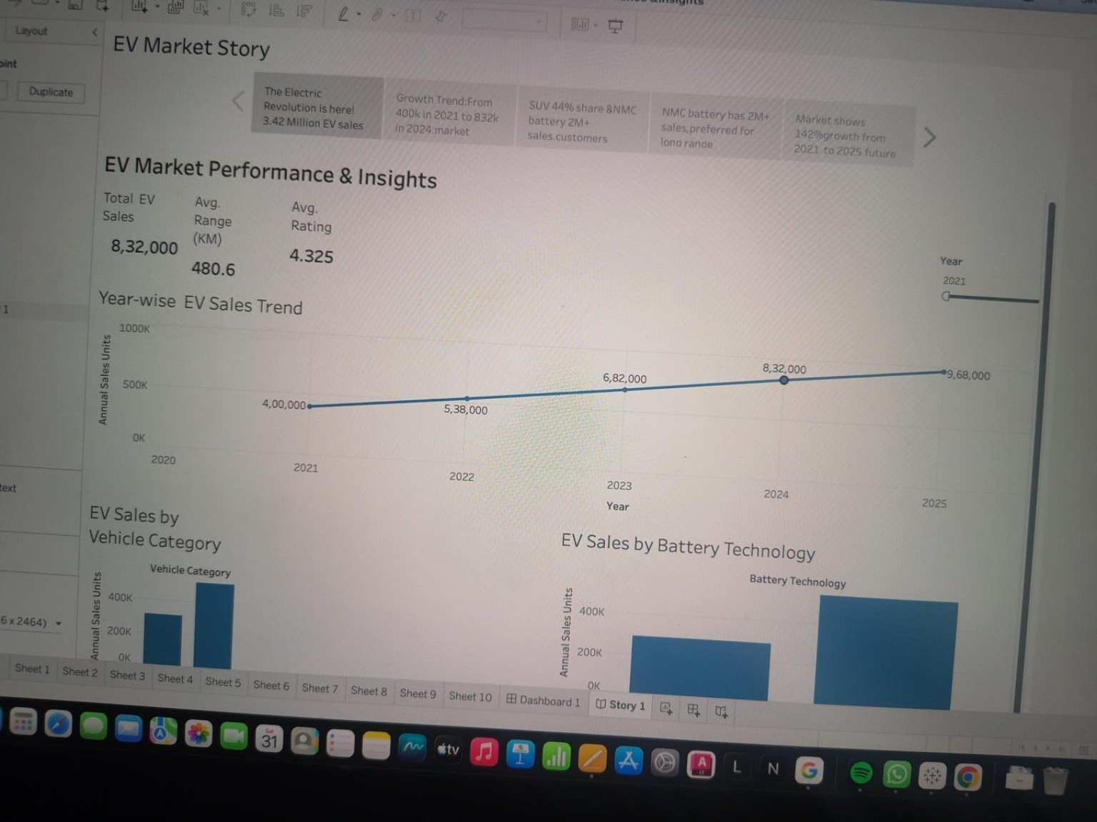

Major Outcomes Observed in the Submitted Dashboard
• The KPI cards display Total EV Sales of 832,000, Average Driving Range of 480.6 km and Average Rating of 4.325.
• The year-wise sales line chart rises from 400,000 in 2021 to 968,000 in 2025, indicating an upward trend in the values shown.
• The vehicle-category chart compares EV sales across categories, including Sedan and SUV in the visible dashboard area.
• The battery technology chart compares LFP and NMC sales; NMC appears higher than LFP in the submitted screenshot.
• The country sales chart compares markets including China, France, Germany, India, Japan, South Korea and the USA.
• The map provides a geographic view of EV sales by country.
• The manufacturer pie chart displays contributions from BYD, Ford, Hyundai, Nissan, Renault, Tata Motors, Tesla and Volkswagen.
• The scatter plot compares average vehicle price with customer rating across the displayed marks.

Design and Interaction Notes
• Use clear titles and KPI labels so users can identify each measure.
• Keep the Year filter visible and verify that it filters the intended dashboard worksheets.
• Use chart legends and tooltips to identify countries, manufacturers and battery technologies.
• Keep the dashboard readable at the published Tableau Public viewing size.
• Drill-down and responsive Streamlit features are not claimed; this is a Tableau dashboard and Story.
Data validation note: the screenshot values differ from the available CSV file profile. Confirm the exact workbook data source before treating these figures as verified dataset totals.

